**Check the difference between two files**

1. Create two files with the .sh extension

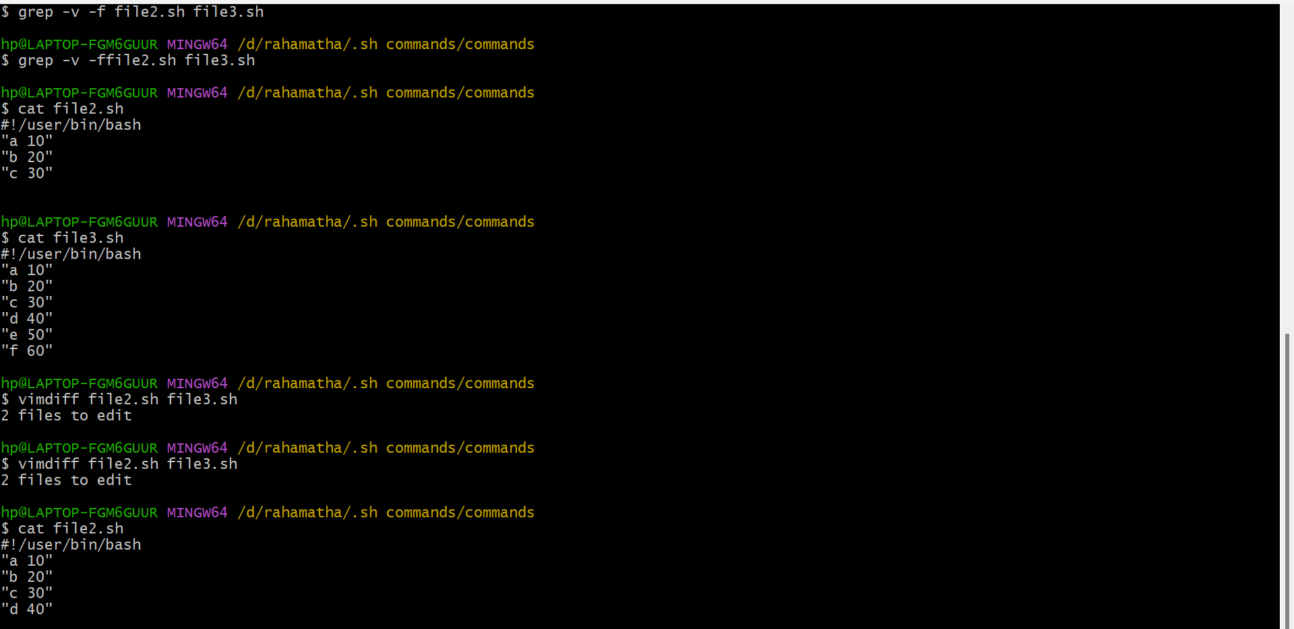

i.Method one

1. vimdiff file1.sh file2.sh

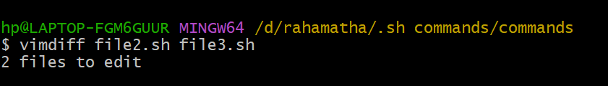

1. You can see the change with the different colour

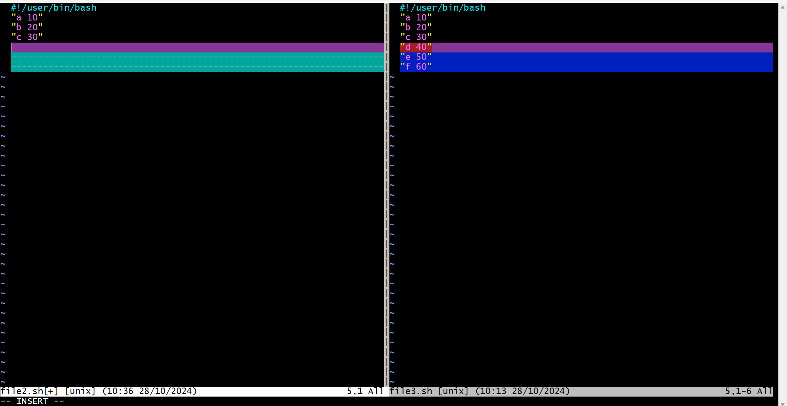

5.you can change the values that we want to edit and save it

ii. Method

1. comm file1.sh file2.sh

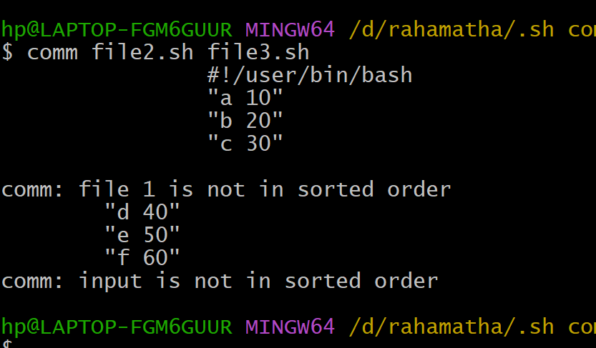

1. here you can see the common data and the difference data

iii. method

1. differ file1.sh file2.sh

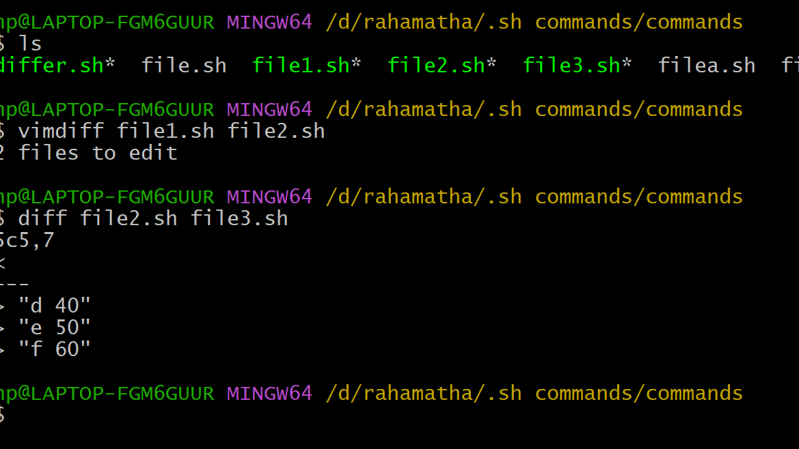

1. it displays the difference data